**SPECIAL WIRES - Products**

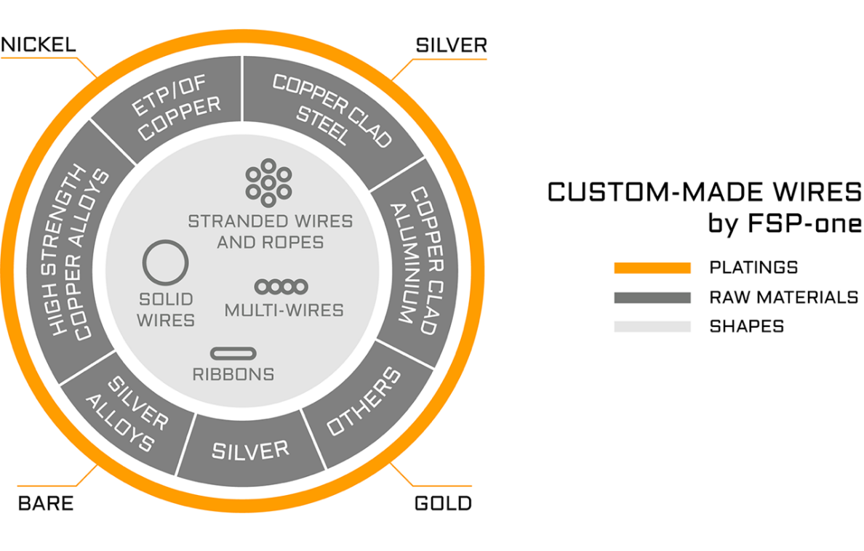

HWA is specialized in manufacturing solid and stranded high-technology conductors following the strict manufacturing standards of FSP-One in France.

HWA special wires consist of a copper or alloyed copper core coated with a precious metal, such as silver or nickel. They are meant for demanding applications requiring both specific mechanical properties and high conductivity.

In most cases, our products are custom-made, and respond to strict specifications from our customers. Applications cover aerospace applications, commercial and military aircrafts, telecommunications, high temperature cables, sub-marine cables and medical applications.

Solid wires diameters typically range from 0.08mm to 1mm. Stranded wires diameters, from 19x0.1mm (or 7x0.1mm) to 19x0.4mm (or 7x0.4mm).

Please submit any specific requirement you may have for special conductors, and we will be glad to provide our best technical offer.